CHEM 330 02 BIOLOGICAL CHEMISTRY
FALL 2024- Exam #2
Name:……………………………………………………………………………………………………..
A) Multiple Choice Section. 20 questions. 2.5 points each. Only one correct option (except question 9). 1.5 min/question

1) Given the following energy diagrams for a reversible reaction between a substrate (A) and a product (B), where the left diagram represents the non-catalyzed reaction, and the right diagram represents the enzymatically catalyzed reaction:

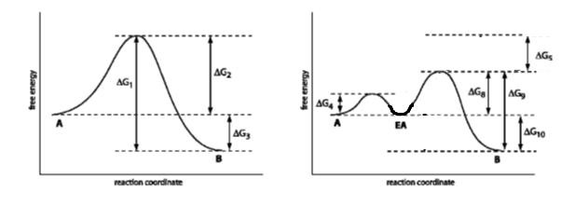
Which ΔG indicates the activation energy of the enzyme-catalyzed reaction? Circle it.

2) The zymogen chymotrypsinogen is converted to active chymotrypsin by:

- Binding of a necessary metal ion
- Reduction of a disulfide bond
- Proteolytic cleavage
- Phosphorylation of an amino acid side chain
- Binding of an allosteric positive effector

3) The types of glycosidic bonds linking monosaccharide units in cellulose are:

A) (α1→ 4) only;
B) (β1→ 4) only;
C) (α1→ 4) and (α1→ 6);
D) (α1→ 4) and (β1→ 6);
E) (β1→ 4) and (α1→ 6).

4) Which of the following diagrams best describes the equilibria associated with an uncompetitive inhibitor (I)?

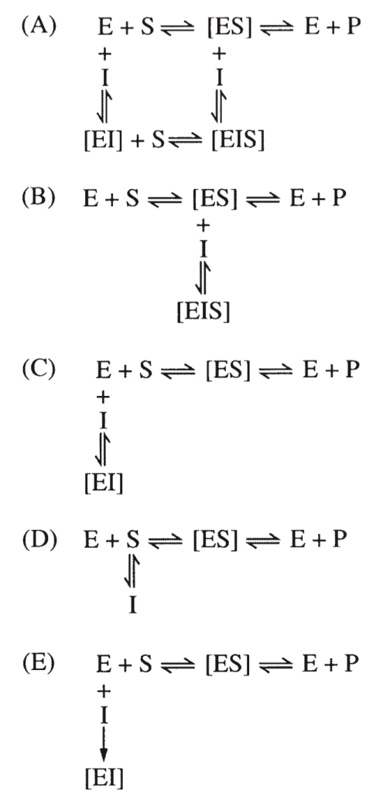

5) Glucose taken up by liver cells is rapidly phosphorylated to glucose 6-phosphate with ATP serving as the phosphate donor in the initial step of metabolism and assimilation of the sugar. Two enzymes, which may be considered isozymes, are capable of catalyzing this reaction in the liver cell. Hexokinase has a low Km of around 0.05 mM for glucose, whereas glucokinase exhibits a Km of around 5 mM. After a large meal, the glucose concentration in the liver is approximately 5 mM. After a meal, which of the following scenarios best describes the relative activity levels for the two enzymes?

Hexokinase Glucokinase
A) not active not active
B) v=Vmax/2 not active
C) v=Vmax v=Vmax
D) v=Vmax/2 v=Vmax/2
E) v=Vmax v=Vmax/2

6) The pH dependencies of Vmax and Km for an enzyme are shown above. These data are most consistent with the requirement for: (Help: remember that the Km gives an indication of the binding affinity of the enzyme for the substrate.)

- A general base in catalysis (P formation)
- A general acid in catalysis (P formation)
- A metal ion in catalysis (P formation)
- A basic residue in substrate binding (ES formation)
- An acidic residue in substrate binding (ES formation)

7) Enzymes have active sites which have the greatest complementarity to the:

A) substrate.
B) transition state.
C) product.
D) both substrate and product.
E) none of the above.

8) As a result of mutarotation, D-glucose exists in all of the following forms EXCEPT:

A) L-glucopyranose.
B) α-anomer.
C) free aldehyde.
D) β-anomer.
E) All are true.

9) The configuration at which carbon of a tetrose determines if the tetrose has the D or L configuration? Tip: tetra means four in Greek.

A) C – 1
B) C – 2
C) C – 3
D) C – 4
E) C – 5

10) Which of the following can act as a nucleophile in enzymatic reactions?
I. Nitrogen of an amino group
II. Oxygen of a hydroxyl group
III. Carbon of a carbonyl group

A) I only
B) II only
C) III only
D) I and II only
E) I, II and III

11) N-linked oligosaccharides can be covalently linked to proteins at the amino acid:

A) glycine
B) serine
C) glutamate
D) tyrosine
E) asparagine

12) The following question refer to the overall transformation:
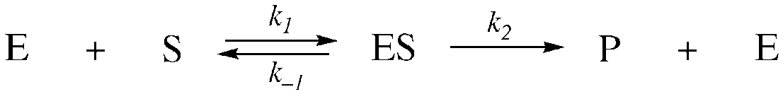

For the reaction, the steady state assumption assumes that
A) [S] = [P]
B) [ES] is constant
C) [P]>>[E]
D) [P] is constant
E) k_{–1}>>k₂

This figure is used in questions 13-15:

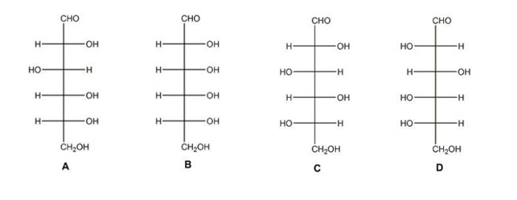

13) Which of the carbohydrates shown in the figure are L carbohydrates?

A) A and B
B) B and C
C) C and D
D) A and D
E) None of the above

14) Which carbohydrate is the enantiomer of carbohydrate A?

A) B
B) C
C) D
D) B and D
E) none of the above

15) Which two carbohydrates shown in the figure are epimers?

A) A and B
B) B and C
C) C and D
D) A and D
E) None of the above

16) Which of the following graphs best shows the results of reaction rate versus substrate concentration for a cooperative enzyme in the absence (solid lines) and presence (dashed lines) of an allosteric inhibitor?
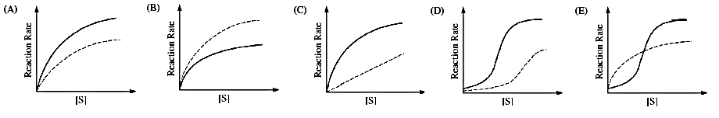
17) Which statement about starch and glycogen is false?

A. Amylose is unbranched; amylopectin and glycogen contain many (α1 → 6) branches.
B. Both are homopolymers of glucose.
C. Both serve primarily as structural elements in cell walls.
D. Both starch and glycogen are stored intracellularly as granules.
E. Glycogen is more extensively branched than starch.

18) Which of following is an anomeric pair?

- D-glucose and D-fructose
- D-glucose and L-fructose
- D-glucose and L-glucose
- α-D-glucose and β-D-glucose
- α-D-glucose and β-L-glucose

19) The product of the following reaction is:

A) cyclic
B) a hemiketal
C) a thioester
D) a hemiacetal
E) an aldehyde

20) The data in the table below were collected for an enzyme-catalyzed reaction. The Km for this enzyme is approximately:

- 2 x 10⁻² mM
- 2 x 10⁻⁵ mM
- 1 x 10⁻² mM
- 8 x 10⁻⁵ mM
- 140 μmol . min⁻¹
- 280 μmol . min⁻¹

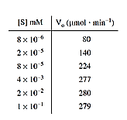

B) Short Answers Section- 5 questions- 10 points each- 4 minutes each
1) Below is the open-chain structure of one isomer of altrose. A) On the backbone provided, draw the cyclic form. B) What is the full name of the sugar you have drawn?

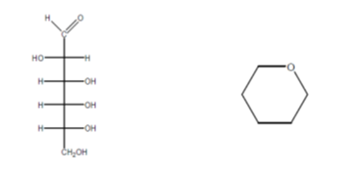
2) HIV belongs to the class of viruses called retroviruses, which carry genetic information in the form of RNA. HIV protease (PR), a virally encoded enzyme, is required to cleave a viral polyprotein precursor into individual mature proteins. According to several studies, HIV PR has been shown to belong to the class of the aspartic proteases. Experimental results are consistent with a general acid–base mechanism, in which aspartate residues play an essential general acid–base role to activate the water molecule that acts as a nucleophile and attacks the carbonyl carbon of the scissile bond (the bond that will break). Examining the sequence homology of HIV PR to other cellular aspartic proteases shows that this enzyme has the sequence Asp-Thr-Gly (one letter code: D-T-G), which is conserved among the aspartic protease enzymes.

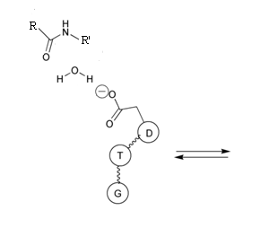
Complete the following diagram of the first reaction in the HIV protease catalytic process, showing:
- curly arrows showing the movement of electrons;
- the structure of the first transition state intermediate.

3) Trehalose (glucose -α,α-1,1-glucose) is a major circulatory sugar that is used for energy in insects. A) Draw this sugar in Haworth projection. B) Is trehalose a reducing sugar? Explain.

4) In the space provided below, draw a segment of a glycogen molecule, including a branch:

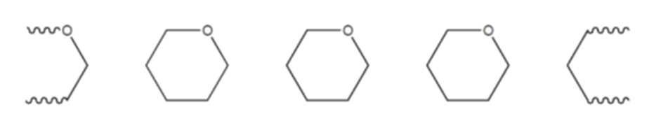
5) Exchange protein activated by cAMP isoform 1 (EPAC1) is an enzyme that is known to regulate a broad array of physiological processes, including calcium homeostasis, insulin secretion from pancreas, etc. The substrate of EPAC1 is cyclic AMP (cAMP). The kinetic data of initial velocity (rate of reaction) as a function of cAMP concentration for EPAC1 were collected and provided below. Reference: Boulton, S; Selvaratnam, R.; Blondeau, J.-P.; Lezoualch, F.; Melacini, G. J.A.C.S. 2018 140 (30), 9624-9637. DOI: 10.1021/jacs.8b05044

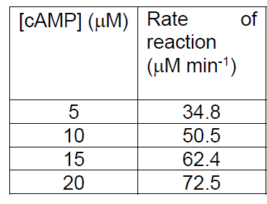

- From the kinetic data provided, generate a table of data appropriate for use to generate a Lineweaver-Burke plot. Make sure to label your column with appropriate names and units.

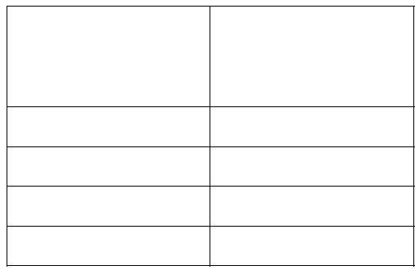

- Plot your data from part (a). Label the axis accordingly. Approximate the Km and Vmax.

